Write a C program demonstrating signal handling.
• Parent process runs indefinitely
• Child process sends SIGTERM after 5 seconds
• Another child sends SIGINT after 10 seconds
• Parent handles each signal differently and exits gracefully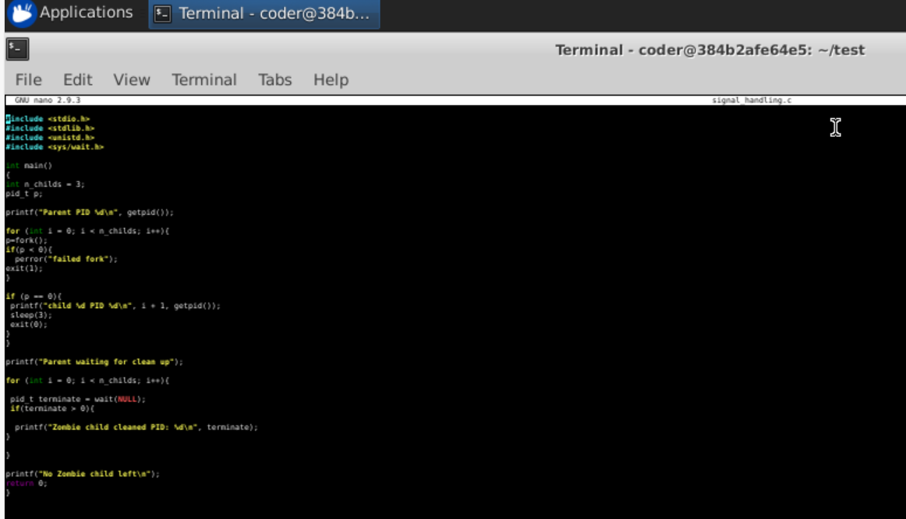
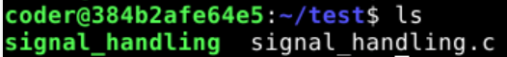
Explanation: Above script runs parent script for indefinite and child process sends signal after 10 seconds. Parent handles it differently and exits at the end.

